**question_keyword :**

ALTER TABLE `question_keyword` ADD CONSTRAINT `CIR_DELETE_KEYWORD_QUESTION-KEYWORD` FOREIGN KEY (`question_keyword_idkeyword`) REFERENCES `keyword`(`keyword_id`) ON DELETE CASCADE ON UPDATE RESTRICT; ALTER TABLE `question_keyword` ADD CONSTRAINT `CIR_DELETE_QUESTION_QUESTION-KEYWORD` FOREIGN KEY (`question_keyword_idquestion`) REFERENCES `question`(`question_id`) ON DELETE CASCADE ON UPDATE RESTRICT;

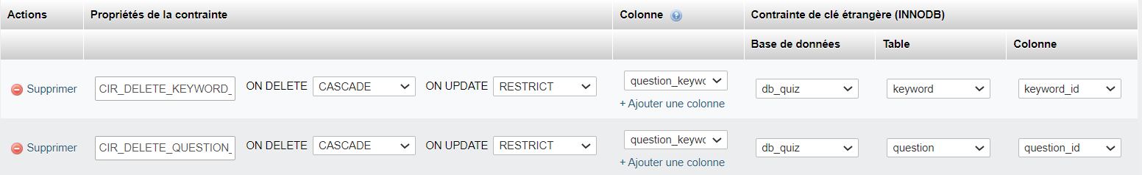

**answer :**

ALTER TABLE `answer` ADD CONSTRAINT `CIR_DELETE_QUESTION_ANSWER` FOREIGN KEY (`answer_idquestion`) REFERENCES `question`(`question_id`) ON DELETE CASCADE ON UPDATE RESTRICT;

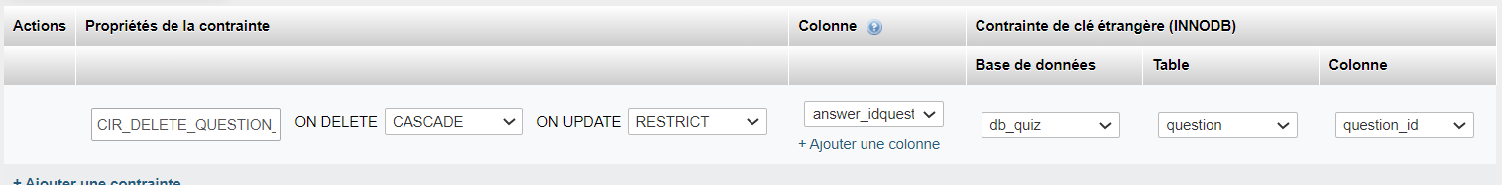

**quizresult :**

ALTER TABLE `quizresult` ADD CONSTRAINT `CIR_DELETE_ACCOUNT_QUIZRESULT` FOREIGN KEY (`quizresult_loginuser`) REFERENCES `account`(`account_login`) ON DELETE CASCADE ON UPDATE RESTRICT;

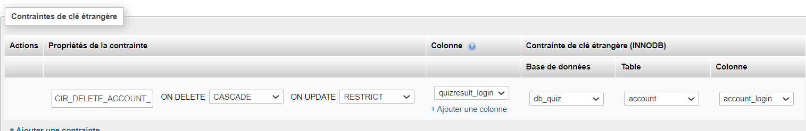

**session_user :**

ALTER TABLE `session_user` ADD CONSTRAINT `CIR_DELETE_ACCOUNT_SESSION-USER` FOREIGN KEY (`session_user_loginuser`) REFERENCES `account`(`account_login`) ON DELETE CASCADE ON UPDATE RESTRICT;

ALTER TABLE `session_user` ADD CONSTRAINT `CIR_DELETE_SESSION_SESSION-USER` FOREIGN KEY (`session_user_idsession`) REFERENCES `session`(`session_id`) ON DELETE CASCADE ON UPDATE RESTRICT;

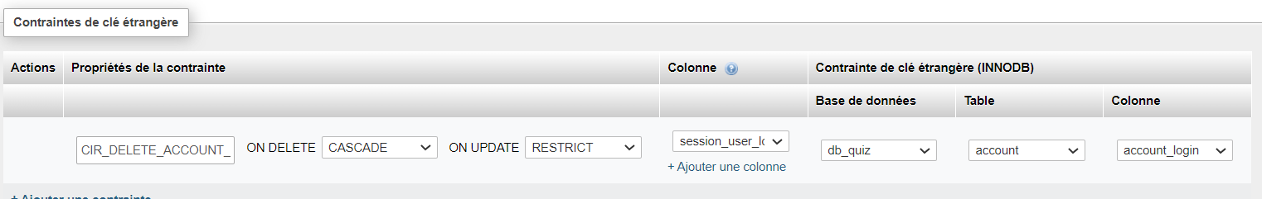

**session_quiz :**

ALTER TABLE `session_quiz` ADD CONSTRAINT `CIR_DELETE_SESSION_SESSION-QUIZ` FOREIGN KEY (`session_quiz_idsession`) REFERENCES `session`(`session_id`) ON DELETE CASCADE ON UPDATE RESTRICT;

ALTER TABLE `session_quiz` ADD CONSTRAINT `CIR_DELETE_QUIZ_SESSION-QUIZ-QUESTION` FOREIGN KEY (`session_quiz_idquiz`) REFERENCES `quiz`(`quiz_id`) ON DELETE CASCADE ON UPDATE RESTRICT;

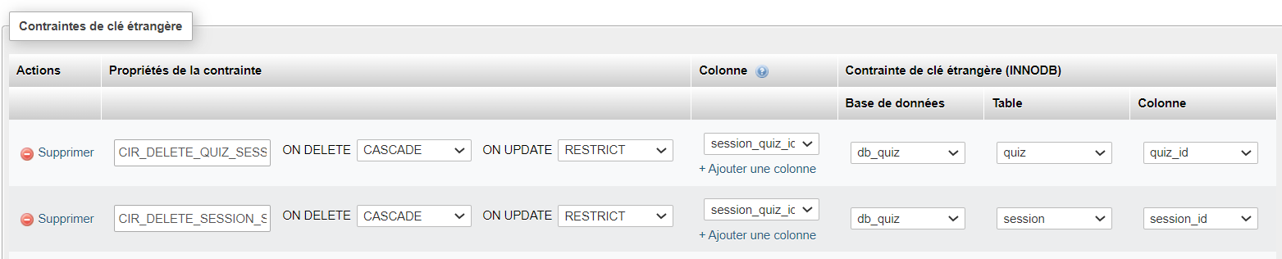

**quizresult_ questionko :**

ALTER TABLE `quizresult_questionko` ADD CONSTRAINT `CIR_DELETE_QUESTION_QUIZRESULT-QUESTIONKO` FOREIGN KEY (`quizresult_questionko_idquestion`) REFERENCES `question`(`question_id`) ON DELETE CASCADE ON UPDATE RESTRICT;

ALTER TABLE `quizresult_questionko` ADD CONSTRAINT `CIR_DELETE_QUIZRESULT_QUIZRESULT-QUESTIONKO` FOREIGN KEY (`quizresult_questionko_idquizresult`) REFERENCES `quizresult`(`quizresult_id`) ON DELETE CASCADE ON UPDATE RESTRICT;

**questionstat :**

ALTER TABLE `questionstat` ADD CONSTRAINT `CIR_DELETE_QUESTION_QUESTIONSTATSWER` FOREIGN KEY (`questionstat_idquestion`) REFERENCES `question`(`question_id`) ON DELETE CASCADE ON UPDATE RESTRICT;

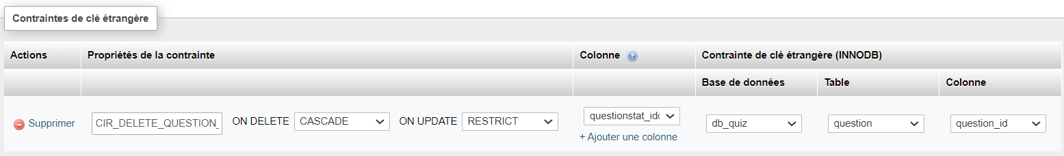

**quiz_question :**

ALTER TABLE `quiz_question` ADD CONSTRAINT `CIR_DELETE_QUESTION_QUIZ-QUESTION` FOREIGN KEY (`quiz_question_idquestion`) REFERENCES `question`(`question_id`) ON DELETE CASCADE ON UPDATE RESTRICT;

ALTER TABLE `quiz_question` ADD CONSTRAINT `CIR_DELETE_QUIZ_QUIZ-QUESTION` FOREIGN KEY (`quiz_question_idquiz`) REFERENCES `quiz`(`quiz_id`) ON DELETE CASCADE ON UPDATE RESTRICT;

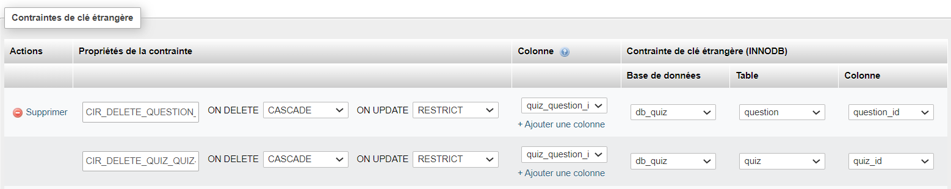

ALTER TABLE `quizlock` ADD CONSTRAINT `CIR_DELETE_QUIZ_QUIZLOCK` FOREIGN KEY (`quizlock_quizid`) REFERENCES `quiz`(`quiz_id`) ON DELETE CASCADE ON UPDATE RESTRICT;

ALTER TABLE `quizlock` ADD CONSTRAINT `CIR_DELETE_ACCOUNT_QUIZLOCK` FOREIGN KEY (`quizlock_user`) REFERENCES `account`(`account_login`) ON DELETE CASCADE ON UPDATE RESTRICT;

**Cannot drop table 'account' referenced by a foreign key constraint 'CIR_DELETE_ACCOUNT_QUIZRESULT' on table 'quizresult'.**

ALTER TABLE quizlock ADD PRIMARY KEY (quizlock_user, quizlock_quizid);

ALTER TABLE session_quiz ADD PRIMARY KEY (`session_quiz_idsession`, `session_quiz_idquiz`);

ALTER TABLE question_keyword ADD PRIMARY KEY (`question_keyword_idquestion`, `question_keyword_idkeyword`);

ALTER TABLE quizresult_questionko ADD PRIMARY KEY (`quizresult_questionko_idquizresult`, `quizresult_questionko_idquestion`);

ALTER TABLE quiz_question ADD PRIMARY KEY (`quiz_question_idquiz`, `quiz_question_idquestion`);

ALTER TABLE session_user ADD PRIMARY KEY (`session_user_idsession`, `session_user_loginuser`);

<button class="button" type="button" id="up_question-keywords-restor" onclick="up_questionKeywordsRestor(<?php echo($strKeywords) ?>)">Restaurer les mots clés d'origine</button>

echo '<button class="button" type="button" id="up_question-keywords-restor" onclick="up_questionKeywordsRestor("'.$strKeywords.'")">Restaurer les mots clés d\'origine</button>';

**-----**

**class_questions_list / __construct :**

SELECT question_id, question_question, question_status, question_lastmodificationdate, question_idwidget,

question_keyword_idquestion, question_keyword_idkeyword

FROM question LEFT JOIN question_keyword ON question_keyword_idquestion = question_id

WHERE question_loginadmin = 'cma'

ORDER BY question_lastmodificationdate DESC

SELECT COUNT(y.question_id) FROM (SELECT question_id, question_keyword_idquestion

FROM question LEFT JOIN question_keyword ON question_keyword_idquestion = question_id

WHERE question_loginadmin = 'cma') AS y >>>> 5

SELECT COUNT(y.question_id) FROM (SELECT DISTINCT question_id

FROM question LEFT JOIN question_keyword ON question_keyword_idquestion = question_id

WHERE question_loginadmin = 'cma') AS y >>>> 3

SELECT COUNT(y. question_keyword_idquestion) FROM (SELECT question_id, question_keyword_idquestion

FROM question LEFT JOIN question_keyword ON question_keyword_idquestion = question_id

WHERE question_loginadmin = 'cma') AS y >>>> 4

* 5 – 4 = 1 NULL

SELECT COUNT(y. question_keyword_idquestion) FROM (SELECT DISTINCT question_keyword_idquestion

FROM question LEFT JOIN question_keyword ON question_keyword_idquestion = question_id

WHERE question_loginadmin = 'cma') AS y >>>> 2

* 3 – 2 = 1 NULL

SELECT DISTINCT keyword_id , keyword_word

FROM question_keyword INNER JOIN keyword ON question_keyword_idkeyword = keyword_id

WHERE keyword_loginadmin = 'cma'

ORDER BY keyword_word ASC

**class_accountresult / getOne() :**

**SELECT quizresult_sessiontitle,quizresult_sessionsubtitle, quizresult_quiztitle, quizresult_quizsubtitle, quizresult_firstnameadmin, quizresult_loginadmin, quizresult_nameadmin, quizresult_startdate, quizresult_enddate, quizresult_maxduration, quizresult_nbquestasked, quizresult_maxnbquest, quizresult_questaskedscore, quizresult_maxquestaskedscore, quizresult_maxscore, quizresult_loginuser, quizresult_idsession, quizresult_idquiz FROM quizresult WHERE quizresult_id = 7**

**class_quiz_userlist / public function __construct($login) :**

SELECT account_name, account_firstname, session_title, session_startdate, session_enddate, session_quiz_openingdate, session_quiz_closingdate, session_quiz_minutesduration, quiz_title, quizresult_id, quizresult_startdate, quizresult_maxscore FROM session_user LEFT JOIN session ON session_id = session_user_idsession LEFT JOIN account ON account_login = session_loginadmin LEFT JOIN session_quiz ON session_quiz_idsession = session_id LEFT JOIN quiz ON quiz_id = session_quiz_idquiz LEFT JOIN quizresult ON quizresult_idquiz = quiz_id WHERE session_user_loginuser = 'chr' ORDER BY session_startdate DESC, session_quiz_openingdate DESC, quizresult_startdate DESC



**____________**

**class_takenquiz / public function __construct($sessionId, $quizId) //Getting general information about session and quiz :**

SELECT session_id, session_title, session_subtitle, quiz_id, quiz_title, quiz_subtitle, session_quiz_minutesduration FROM session LEFT JOIN session_quiz ON session_id = 1 AND session_quiz_idsession = session_id AND session_quiz_idquiz = 1 LEFT JOIN quiz ON quiz_id = session_quiz_idquiz WHERE quiz_status = 'inline'



**class_takenquiz / public function __construct($sessionId, $quizId) //Getting questions and answers :**

SELECT question_id, question_question, question_guideline, widget_name, quiz_question_weight, quiz_question_numorder, answer_idquestion, answer_answer, answer_ok FROM quiz_question LEFT JOIN question ON quiz_question_idquiz = 1 AND question_id = quiz_question_idquestion LEFT JOIN answer ON answer_idquestion = question_id LEFT JOIN widget ON widget_id = question_idwidget WHERE question_status = 'inline' AND answer_status = 'inline'

V1 ko

Array (

[0] => Array (

[0] => 1 [1] => De quelle couleur est le ciel ? [2] => [3] => radio buton [4] => 1 [5] => 0   
[6] => Array ( [0] => 1 [1] => Bleu [2] => 1 )   
[7] => Array ( [0] => 1 [1] => Blanc [2] => 0 )

)

[1] => Array (

[0] => 1 [1] => De quelle couleur est le ciel ? [2] => [3] => radio buton [4] => 1 [5] => 0  
[6] => Array ( [0] => 1 [1] => Rouge [2] => 0 )

)

[2] => Array (

[0] => 2 [1] => Quelle est la couleur de la mer ? [2] => [3] => radio buton [4] => 1 [5] => 0  
[6] => Array ( [0] => 2 [1] => Bleu [2] => 0 )

)

[3] => Array (

[0] => 2 [1] => Quelle est la couleur de la mer ? [2] => [3] => radio buton [4] => 1 [5] => 0  
[6] => Array ( [0] => 2 [1] => Jaune [2] => 0 )

)

[4] => Array (

[0] => 2 [1] => Quelle est la couleur de la mer ? [2] => [3] => radio buton [4] => 1 [5] => 0   
[6] => Array ( [0] => 2 [1] => Grise [2] => 1 )

)

[5] => Array (

[0] => 3 [1] => Quel est la couleur de tes yeux ? [2] => [3] => radio buton [4] => 1 [5] => 0   
[6] => Array ( [0] => 3 [1] => Rouge [2] => 0 )

)

[6] => Array (

[0] => 3 [1] => Quel est la couleur de tes yeux ? [2] => [3] => radio buton [4] => 1 [5] => 0  
[6] => Array ( [0] => 3 [1] => Noir [2] => 0 )

)

[7] => Array (

[0] => 3 [1] => Quel est la couleur de tes yeux ? [2] => [3] => radio buton [4] => 1 [5] => 0   
[6] => Array ( [0] => 3 [1] => Gris [2] => 1 )

)

)

**V2 ok**

Array (

[0] => Array ( [0] => **1** [1] => De quelle couleur est le ciel ? [2] => [3] => radio buton [4] => 1 [5] => 0

[6] => **1** [7] => Blanc [8] => 0 )

[1] => Array ( [0] => **1** [1] => De quelle couleur est le ciel ? [2] => [3] => radio buton [4] => 1 [5] => 0

[6] => **1** [7] => Rouge [8] => 0 )

[2] => Array ( [0] => **1** [1] => De quelle couleur est le ciel ? [2] => [3] => radio buton [4] => 1 [5] => 0

[6] => **1** [7] => Bleu [8] => 1 ) //ok

[3] => Array ( [0] => 2 [1] => Quelle est la couleur de la mer ? [2] => [3] => radio buton [4] => 1 [5] => 0 [6] => 2 [7] => Bleu [8] => 0 ) [4] => Array ( [0] => 2 [1] => Quelle est la couleur de la mer ? [2] => [3] => radio buton [4] => 1 [5] => 0 [6] => 2 [7] => Jaune [8] => 0 ) [5] => Array ( [0] => 2 [1] => Quelle est la couleur de la mer ? [2] => [3] => radio buton [4] => 1 [5] => 0 [6] => 2 [7] => Grise [8] => 1 ) [6] => Array ( [0] => 3 [1] => Quel est la couleur de tes yeux ? [2] => [3] => radio buton [4] => 1 [5] => 0 [6] => 3 [7] => Rouge [8] => 0 ) [7] => Array ( [0] => 3 [1] => Quel est la couleur de tes yeux ? [2] => [3] => radio buton [4] => 1 [5] => 0 [6] => 3 [7] => Noir [8] => 0 ) [8] => Array ( [0] => 3 [1] => Quel est la couleur de tes yeux ? [2] => [3] => radio buton [4] => 1 [5] => 0 [6] => 3 [7] => Gris [8] => 1 ) )

V3 : Avec un tri aléatoire suivi d’un groupe by questionId :

Cf résultat ci-dessus

SELECT

question_id, question_question, question_guideline, widget_name, quiz_question_weight, quiz_question_numorder,

answer_idquestion, answer_answer, answer_ok

FROM quiz_question

LEFT JOIN question ON quiz_question_idquiz = **1** AND question_id = quiz_question_idquestion

LEFT JOIN answer ON answer_idquestion = question_id

LEFT JOIN widget ON widget_id = question_idwidget

WHERE question_status = 'inline' AND answer_status = 'inline'

ORDER BY question_id, answer_ok

Avec tri :

SELECT

question_id, question_question, question_guideline, widget_name, quiz_question_weight, quiz_question_numorder,

answer_idquestion, answer_answer, answer_ok

FROM quiz_question

LEFT JOIN question ON quiz_question_idquiz = **1** AND question_id = quiz_question_idquestion

LEFT JOIN answer ON answer_idquestion = question_id

LEFT JOIN widget ON widget_id = question_idwidget

WHERE question_status = 'inline' AND answer_status = 'inline'

ORDER BY RAND()

Soit :

SELECT randomset.* FROM (

SELECT question_id, question_question, question_guideline, widget_name, quiz_question_weight, quiz_question_numorder, answer_idquestion, answer_answer, answer_ok FROM quiz_question LEFT JOIN question ON quiz_question_idquiz = **1** AND question_id = quiz_question_idquestion LEFT JOIN answer ON answer_idquestion = question_id LEFT JOIN widget ON widget_id = question_idwidget WHERE question_status = 'inline' AND answer_status = 'inline' ORDER BY RAND()

) AS randomset

// liste des questions :

SELECT question_id FROM quiz_question, question WHERE question_status = 'inline' AND quiz_question_idquiz = **1** AND question_id = quiz_question_idquestion ORDER BY RAND()

SELECT

distinct a.ID,

a.col2,

(SELECT

SUM(b.size)

FROM

tableb b

WHERE

b.id = a.col3)

FROM

tablea a

SELECT rq.question_id, rq.question_question, rq.question_guideline,

ra.quiz_question_weight, ra.quiz_question_numorder, ra.answer_idquestion, ra.answer_answer, ra.answer_ok, ra.widget_name

FROM ( SELECT question_id, question_question, question_guideline FROM quiz_question, question WHERE question_status = 'inline' AND quiz_question_idquiz = **1** AND question_id = quiz_question_idquestion ORDER BY RAND() ) AS rq,

(SELECT question_id, question_question, question_guideline, widget_name, quiz_question_weight, quiz_question_numorder, answer_idquestion, answer_answer, answer_ok FROM quiz_question LEFT JOIN question ON quiz_question_idquiz = **1** AND question_id = quiz_question_idquestion LEFT JOIN answer ON answer_idquestion = question_id LEFT JOIN widget ON widget_id = question_idwidget WHERE question_status = 'inline' AND answer_status = 'inline' ORDER BY RAND()) AS ra

WHERE ra.question_id = rq.question_id

1. <!DOCTYPE html PUBLIC "-*//W3C//DTD XHTML 1.0 Strict//EN"*
2. "http://www.w3.org/TR/xhtml1/DTD/xhtml1-strict.dtd">
3. <html xmlns="http://www.w3.org/1999/xhtml" xml:lang="en" >
4. <head>
5. <meta http-equiv="content-type" content="text/html; charset=iso-8859-1" />
6. <title>Exemple</title>
7. <script type="text/javascript">
8. var pouet = false;
9. window.onbeforeunload = function (){
10. if ( pouet == false){
11. return false;
12. }
13. }
14. function goToUrl(url){
15. pouet = true;
16. document.location.href = url;
17. return false;
18. }
19. </script>
20. </head>
21. <body>
22. <a href="http://www.google.com">lien normal</a><br/>
23. <a href="" onclick="return goToUrl('http://www.google.com')">lien perso</a>
24. </body>
25. </html>

//Getting questions and answers all at random :

* ORDER BY RAND(), quiz_question_numorder : ko
* **ORDER BY quiz_question_numorder, RAND() : ok**
* ORDER BY quiz_question_numorder, question_id, RAND() : ko : questions 0 tjrs ds le même ordre
* ORDER BY quiz_question_numorder, RAND(), question_id : ko

A priori, ce qui est placé après RAND() n’est pas pris en compte

SELECT question_id, question_question, question_guideline, widget_id, quiz_question_weight, quiz_question_numorder, answer_idquestion, answer_answer, answer_ok, answer_id

FROM quiz_question

LEFT JOIN question ON quiz_question_idquiz = 1 AND question_id = quiz_question_idquestion

LEFT JOIN answer ON answer_idquestion = question_id

LEFT JOIN widget ON widget_id = question_idwidget

WHERE question_status = 'inline' AND answer_status = 'inline'

ORDER BY quiz_question_numorder, RAND(), question_id

**class_questions_list / __construct($login) :**

SELECT question_id, question_question, question_status, question_lastmodificationdate, question_idwidget, question_keyword_idkeyword

FROM question LEFT JOIN question_keyword ON question_keyword_idquestion = question_id

WHERE question_loginadmin = 'cma'

ORDER BY question_id DESC

**class_keywords_list / __construct($login) :**

SELECT y.keyword_id, y.keyword_word, COUNT(*) FROM

(SELECT keyword_id, keyword_word, question_keyword_idkeyword

FROM keyword LEFT JOIN question_keyword ON question_keyword_idkeyword = keyword_id

WHERE keyword_loginadmin = 'cma' AND question_keyword_idkeyword IS NOT NULL) AS y

GROUP BY y.keyword_id

SELECT keyword_id, keyword_word, question_keyword_idkeyword

FROM keyword LEFT JOIN question_keyword ON question_keyword_idkeyword = keyword_id

WHERE keyword_loginadmin = 'cma' AND question_keyword_idkeyword IS NULL

(

SELECT y.keyword_id, y.keyword_word, COUNT(*) AS count FROM

(SELECT keyword_id, keyword_word, question_keyword_idkeyword

FROM keyword LEFT JOIN question_keyword ON question_keyword_idkeyword = keyword_id

WHERE keyword_loginadmin = 'cma' AND question_keyword_idkeyword IS NOT NULL) AS y

GROUP BY y.keyword_id

) UNION

(

SELECT keyword_id, keyword_word, question_keyword_idkeyword

FROM keyword LEFT JOIN question_keyword ON question_keyword_idkeyword = keyword_id

WHERE keyword_loginadmin = 'cma' AND question_keyword_idkeyword IS NULL

)

**class_keywords_list / __construct($login) / constructKeywordsQuestionsList($login) :**

SELECT **question_keyword_idkeyword**, question_question

FROM question_keyword

LEFT JOIN question ON question_id = **question_keyword_idquestion**

LEFT JOIN keyword ON **keyword**_id = **question_keyword_idkeyword**

WHERE keyword_loginadmin = 'cma'

ORDER BY **question_keyword_idkeyword**, question_lastmodificationdate DESC

SELECT question_question, question_id**, question_keyword_idkeyword**

FROM question_keyword

LEFT JOIN question ON question_id = **question_keyword_idquestion**

LEFT JOIN keyword ON **keyword**_id = **question_keyword_idkeyword**

WHERE keyword_loginadmin = 'cma'

ORDER BY **question_id**

question_lastmodificationdate DESC

SELECT a.quiz_id, a.quiz_title, a.quiz_subtitle, a.quiz_status, a.quiz_creationdate, a.quiz_lastmodificationdate, a.ycountquestions, b.zcountsessions FROM

(

(SELECT quiz_id, quiz_title, quiz_subtitle, quiz_status, quiz_creationdate, quiz_lastmodificationdate, COUNT(*) AS ycountquestions FROM

(SELECT quiz_id, quiz_title, quiz_subtitle, quiz_status, quiz_creationdate, quiz_lastmodificationdate FROM quiz_question, quiz WHERE quiz_loginadmin = 'cma' AND quiz_id = quiz_question_idquiz) AS y

GROUP BY quiz_id)

UNION

(SELECT quiz_id, quiz_title, quiz_subtitle, quiz_status, quiz_creationdate, quiz_lastmodificationdate, quiz_question_idquiz FROM quiz LEFT JOIN quiz_question ON quiz_id = quiz_question_idquiz WHERE quiz_loginadmin = 'cma' AND quiz_question_idquiz IS NULL)

) AS a,

(

(SELECT quiz_id, COUNT(*) AS zcountsessions FROM

(SELECT quiz_id FROM session_quiz, quiz, session WHERE quiz_loginadmin = 'cma' AND quiz_id = session_quiz_idquiz

AND session_id = session_quiz_idsession AND (session_enddate IS NULL OR (UTC_TIMESTAMP() < FROM_UNIXTIME(session_enddate)))

) AS z

GROUP BY quiz_id)

UNION

(SELECT quiz_id, session_quiz_idquiz FROM quiz LEFT JOIN session_quiz ON quiz_id = session_quiz_idquiz WHERE quiz_loginadmin = 'cma' AND session_quiz_idquiz IS NULL)

) AS b

WHERE a.quiz_id = b.quiz_id

ORDER BY a.quiz_id DESC

Time :

Time ++ :

Avec un quiz sans question mais avec une session :

Sans time :

SELECT a.quiz_id, a.quiz_title, a.quiz_subtitle, a.quiz_status, a.quiz_creationdate, a.quiz_lastmodificationdate, a.ycountquestions, b.zcountsessions FROM

(

(SELECT quiz_id, quiz_title, quiz_subtitle, quiz_status, quiz_creationdate, quiz_lastmodificationdate, COUNT(*) AS ycountquestions FROM

(SELECT quiz_id, quiz_title, quiz_subtitle, quiz_status, quiz_creationdate, quiz_lastmodificationdate FROM quiz_question, quiz WHERE quiz_loginadmin = 'cma' AND quiz_id = quiz_question_idquiz) AS y

GROUP BY quiz_id)

UNION

(SELECT quiz_id, quiz_title, quiz_subtitle, quiz_status, quiz_creationdate, quiz_lastmodificationdate, quiz_question_idquiz FROM quiz LEFT JOIN quiz_question ON quiz_id = quiz_question_idquiz WHERE quiz_loginadmin = 'cma' AND quiz_question_idquiz IS NULL)

) AS a,

(

(SELECT quiz_id, COUNT(*) AS zcountsessions FROM

(SELECT quiz_id FROM session_quiz, quiz WHERE quiz_loginadmin = 'cma' AND quiz_id = session_quiz_idquiz) AS z

GROUP BY quiz_id)

UNION

(SELECT quiz_id, session_quiz_idquiz FROM quiz LEFT JOIN session_quiz ON quiz_id = session_quiz_idquiz WHERE quiz_loginadmin = 'cma' AND session_quiz_idquiz IS NULL)

) AS b

WHERE a.quiz_id = b.quiz_id

ORDER BY a.quiz_id DESC

**Test maj quiz :**

**Départ :**

* Quiz ‘Couleurs’
  + Ciel (0, 1) >>>>>>> update 4, 3
  + yeux (0, 1) >>>>>>> RAS (0, 1)
  + mer (0, 1) >>>>>>> supp
* Soustitre: parentheses ôtées

**Opérations :**

1. + Q2 >>>>>>> créa 4, 3
2. X ciel
3. + ciel
4. Maj ciel : 4, 3
5. + Q3
6. X Q3
7. X mer
8. Maj Q2 : 4, 3

**Résultat 1 :**

Quiz :  
updatedquizdid (QUIZID) : 1   
updatedquiz (old quiz) : Couleurs  
up_quiz : 1 (Soustitre: parentheses ôtées)  
quiz_title (new quiz) : Couleurs  
quiz_title_old (old quiz) : Couleurs  
quiz_subtitle : sous-titre bidon (Soustitre: parentheses ôtées)  
quiz_subtitle_old : (sous-titre bidon)  
quiz_status : inline  
quiz_status_old : inline  
  
Questions :  
nb-questions_original : 3  
  
Old questions to detete :  
  
deleteQuestion(1) : inline - 20230208 - De quelle couleur est le ciel ?  
deleteQuestion(2) : inline - 20230208 - Quelle est la couleur de la mer ?   
  
Old answers to update :  
  
  
New answers to create :  
nb-max-questions-new : 3  
  
  
createQuestion(draft - checkbox - Q2, 4, 3) **>>create = add => id needed**createQuestion(inline - radio - De quelle couleur est le ciel ?, 4, 3) **>>détecter le vieux ciel et le passer en ‘ ‘**

**Résultat 2 :**

Quiz :  
updatedquizdid (QUIZID) : 1  
updatedquiz (old quiz) : Couleurs  
up_quiz : 0  
quiz_title (new quiz) : Couleurs  
quiz_title_old (old quiz) : Couleurs  
quiz_subtitle : (sous-titre bidon)  
quiz_subtitle_old : (sous-titre bidon)  
quiz_status : inline  
quiz_status_old : inline  
  
Questions :  
nb-questions_original : 3  
  
Old questions to detete :  
  
deleteQuestion(2) : inline - checkbox - Quelle est la couleur de la mer ?  
  
Old answers to update :  
  
updateQuestion(1, 4, 3) : inline - radio - De quelle couleur est le ciel ?  
  
New answers to create :  
nb-max-questions-new : 2  
  
  
createQuestion(25, 4, 3) : inline - radio - De quelle couleur est le ciel ?